Lecture 17-18

2D Game in Unity

1. Start with making a new “2D” game
2. Give it name Dino game
3. Import following 2D game asset to the game from asset store:

<https://assetstore.unity.com/packages/2d/environments/free-platform-game-assets-85838>

1. Drag and drop Background from BackGround folder and place it on Default layer in sorting layer option
2. Add another layer, name it as “Grass layer”
3. Go to GameObject🡪2D Objects 🡪TileMap and add tilemap (Rectangular) in the hierarchy
4. Place tilemap on grass layer
5. Goto windows🡪2D🡪TilePallet and add new tile pallet for the tilemap
6. Drag and drop Grass patterns from tiles folder, whichever are suitable for your 2D game
7. Apply a Tilemap collider 2D and composite collider 2D on the tilemap
8. Import Dino Asset provided to you on google classroom and place it on grass layer
9. Make a new Game Object and add sprite renderer to it as component
10. Assign it some idle sprite from dino folder
11. Add a box collider 2D at the top of dino and a circular collider 2D at the lower side of dino as shown below:

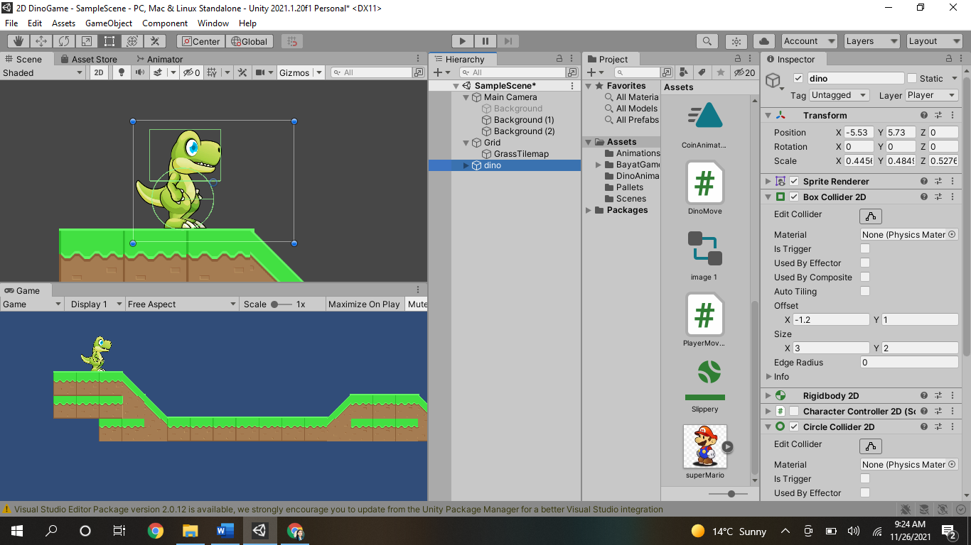

1. Add rididbody 2D to the dino
2. Extend background by making more copies of it
3. You can make camera child of dino or give it some offset in script so that it moves with the dino